31.63: a) 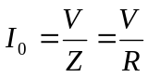 at resonance since 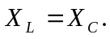
b) 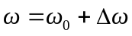 is small compared to 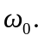
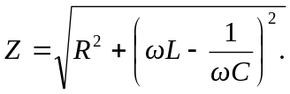
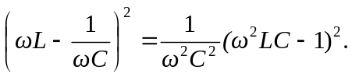
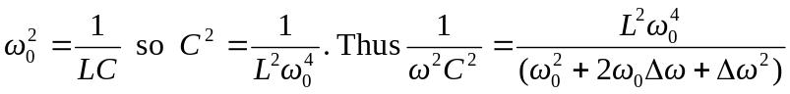
but 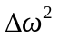 is very small so
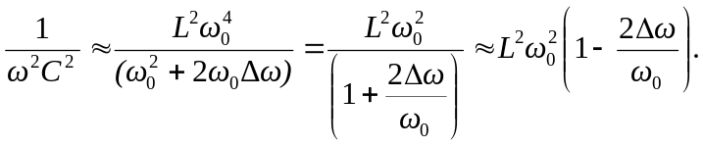
Again, 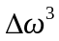 is very small compared to 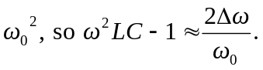
Putting this together gives
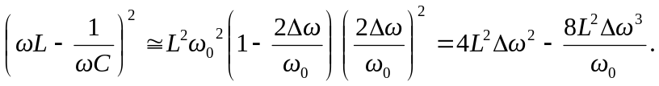
But 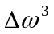is much smaller than Finally
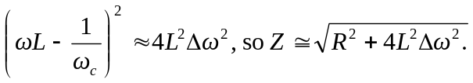
c) 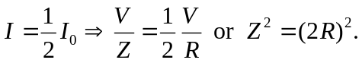
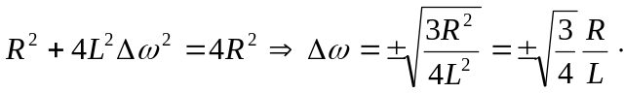
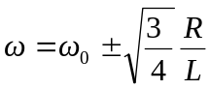 but 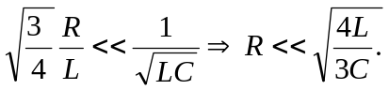
d) 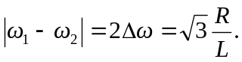 As R increases so does the width.
e) (i) 